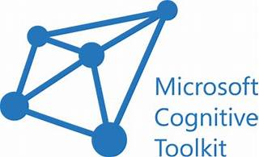

Explore

The **Microsoft Cognitive Toolkit (CNTK)** is an **open-source toolkit** designed for **commercial-grade distributed deep learning**. It represents neural networks as a series of computational steps using a directed graph, allowing users to easily create and combine popular model types such as feed-forward DNNs, convolutional neural networks (CNNs), and recurrent neural networks (RNNs/LSTMs). CNTK supports **stochastic gradient descent (SGD)** with automatic differentiation and parallelization across multiple GPUs and servers. [Additionally, it is one of the first deep-learning toolkits to support the **Open Neural Network Exchange (ONNX)** format, enabling seamless model transfer between frameworks like CNTK, Caffe2, MXNet, and PyTorch1](https://learn.microsoft.com/en-us/cognitive-toolkit/).

Here are **five reference links** where you can learn more about CNTK for free:

1. [**Microsoft Learn - Cognitive Toolkit**](https://learn.microsoft.com/en-us/cognitive-toolkit/): Explore official documentation, tutorials, and resources.
2. [**CNTK GitHub Repository**](https://github.com/microsoft/CNTK): Access the source code, community contributions, and updates.
3. [**Getting Started Tutorial**](https://learn.microsoft.com/en-us/cognitive-toolkit/tutorial/tutorial): Learn the basics of CNTK and get started with creating learning machines.
4. [**CNTK Wiki**](https://github.com/microsoft/CNTK): Dive deeper into specific topics, best practices, and advanced features.
5. **ONNX Format Documentation**: Understand how CNTK supports the ONNX format for model interoperability and optimization.

Happy learning! 🚀🤖